Ideation Phase
Empathize & Discover

Date | 31 January 2025
Team ID | LTVIP2025TMID38720
Project Name | TrafficTelligence: Advanced Traffic Volume Estimation with Machine Learning
Maximum Marks | 4 Marks

Empathy Map Canvas:
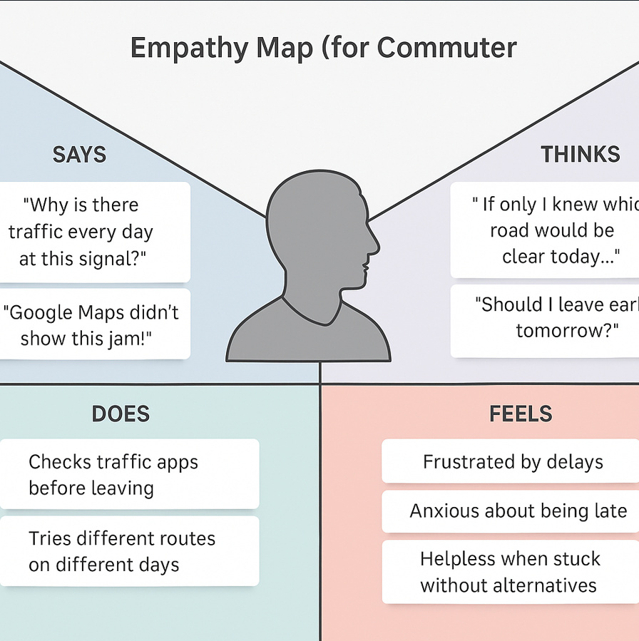
Example:

Reference: https://www.mural.co/templates/empathy-map-canvas

Domain: TrafficTelligence – Smart Traffic Estimation System
Persona: A daily urban commuter
Problem: Wants to reach office on time but gets delayed due to unpredictable traffic
Empathy Map Use: Understand commuter frustrations, behaviors, and needs during daily travel
Traffic Intelligence Application
A working professional commutes daily through heavy traffic zones. Despite using navigation apps, unexpected jams and inaccurate predictions cause frequent delays. An empathy map helps uncover what they say, think, do, and feel to better design solutions using predictive AI traffic models.

